

**Machine Learning**

Project Proposal

Submitted by:

Abhishek Kumar (2K19/CO/020)

Abhishek Kumar Singh (2K19/CO/021)

**AI Chatbot**

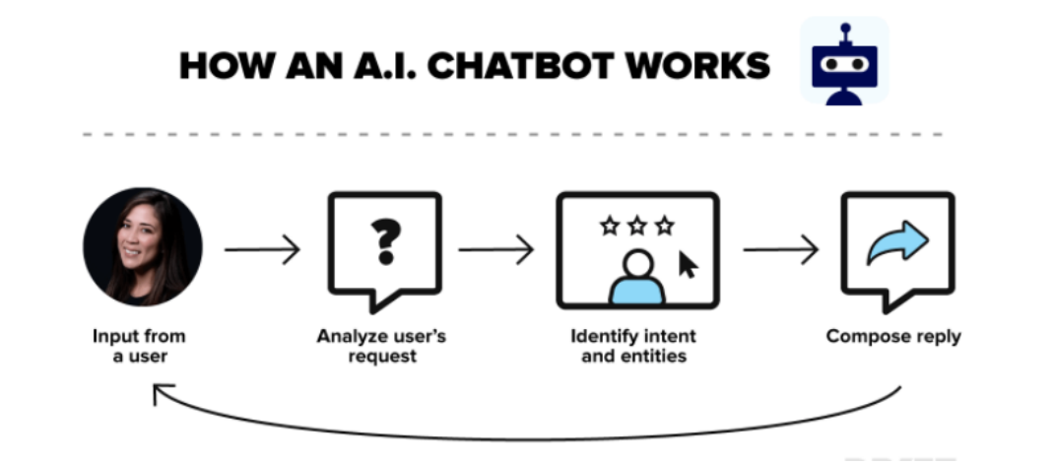

The chatbot will be able to respond according to the user’s response, the chatbot will collect a certain amount of data in order to answer the queries by the users. The data can be extracted from a CSV file or Web Page in order to build a better chat response system.

Also, our main goal is to design the chatbot in such a way that it doesn't respond with repeated answers. For example, if the user type hey twice, the chatbot will be able to respond with different responses (hello, greetings, etc).

**Type of Work**

Implementation